**Software Testing 3rd Year Final Project**

**Business Requirements Document**

**G00377375 – Yassine Jdair**

**Customer:** YouTube

**Main Features:**

SignIn

SignUp

Change Language

Password Reset

Search Function

Update Profile

**Introduction**

I decided to test YouTube. I use this site multiple times a day whether it be catching up on vlogs, watching how to videos or just for entertainment. YouTube is a video sharing service where users can watch, like, share, comment and upload their own videos. The video service can be accessed on PC’s, laptops, tablets, mobile phones, TVs, and majority of gaming consoles. It was launches on February 14th, 2005, by Steve Chen, Chad Hurley, and Jawed Karim. It is Owned by google and it is the second most visited website, right after Google.

**Feature to test Company Logo is visible:**

1. Launch www.youtube.com
2. The screenshot below shows that the YouTube logo is shown on the top left corner.

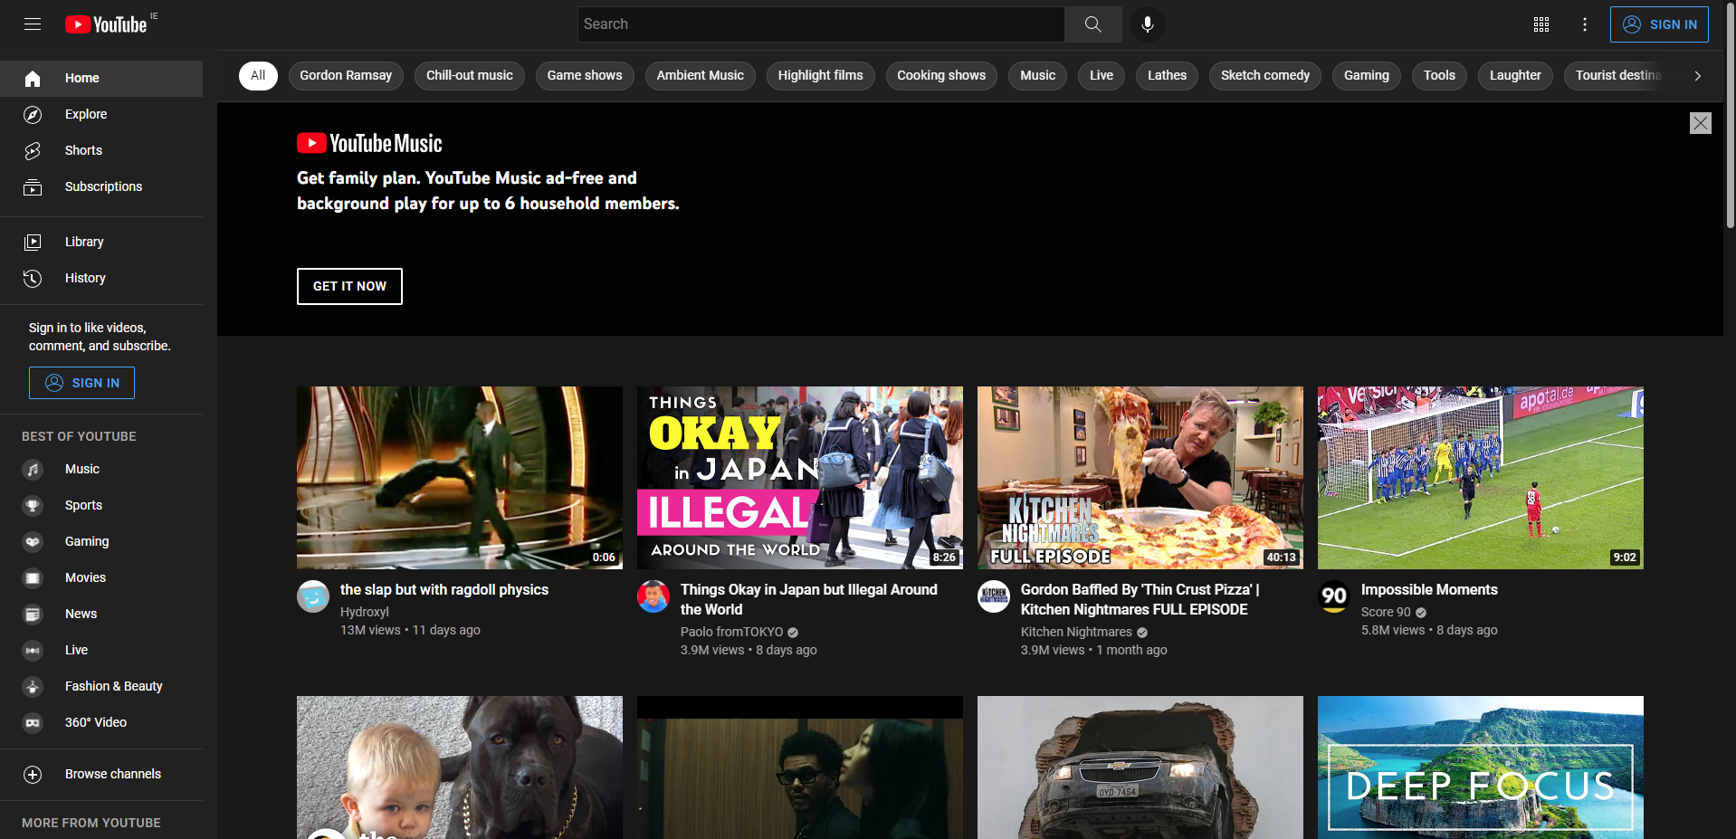

**Feature to test Language:**

1. Launch http://www.youtube.com
2. By Reading through the basic text in the screenshot above the language is in English.

**Feature to test change of language (NotLoggedin):**

1. Browse to http://www.youtube.com
2. Click 3 buttons located on top right beside sign in
3. Click language icon in the drop-down menu
4. Select preferred language.

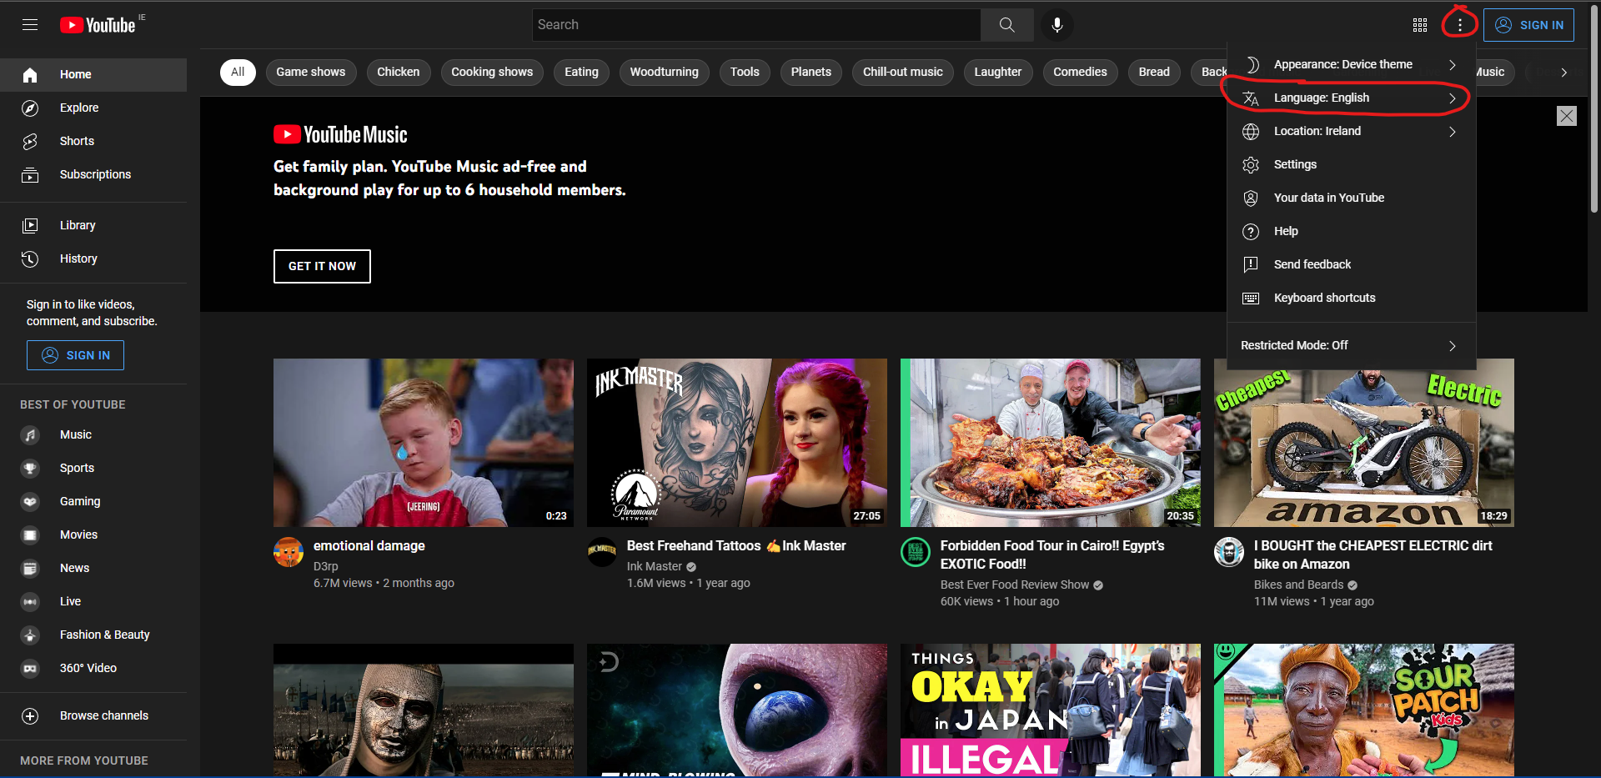

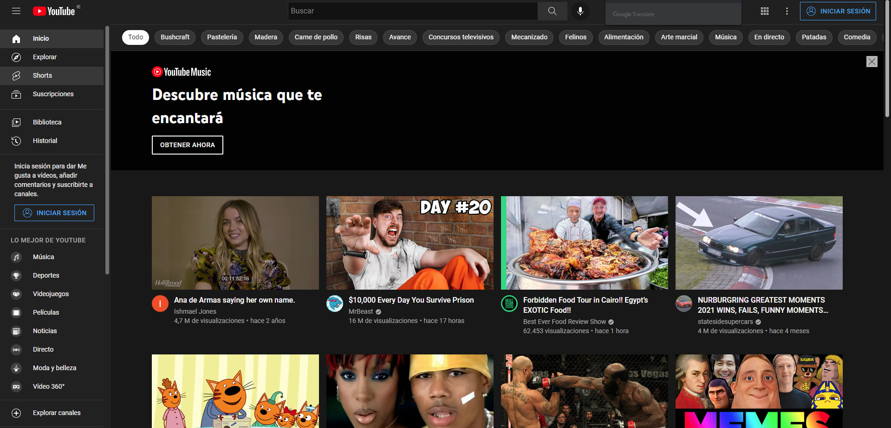

**Feature to test change of language (Loggedin):**

1. Browse to http://www.youtube.com
2. Click User Icon located on top right
3. Click language icon in the drop-down menu
4. Select preferred language.

**Language Changes successfully depending on language chosen**

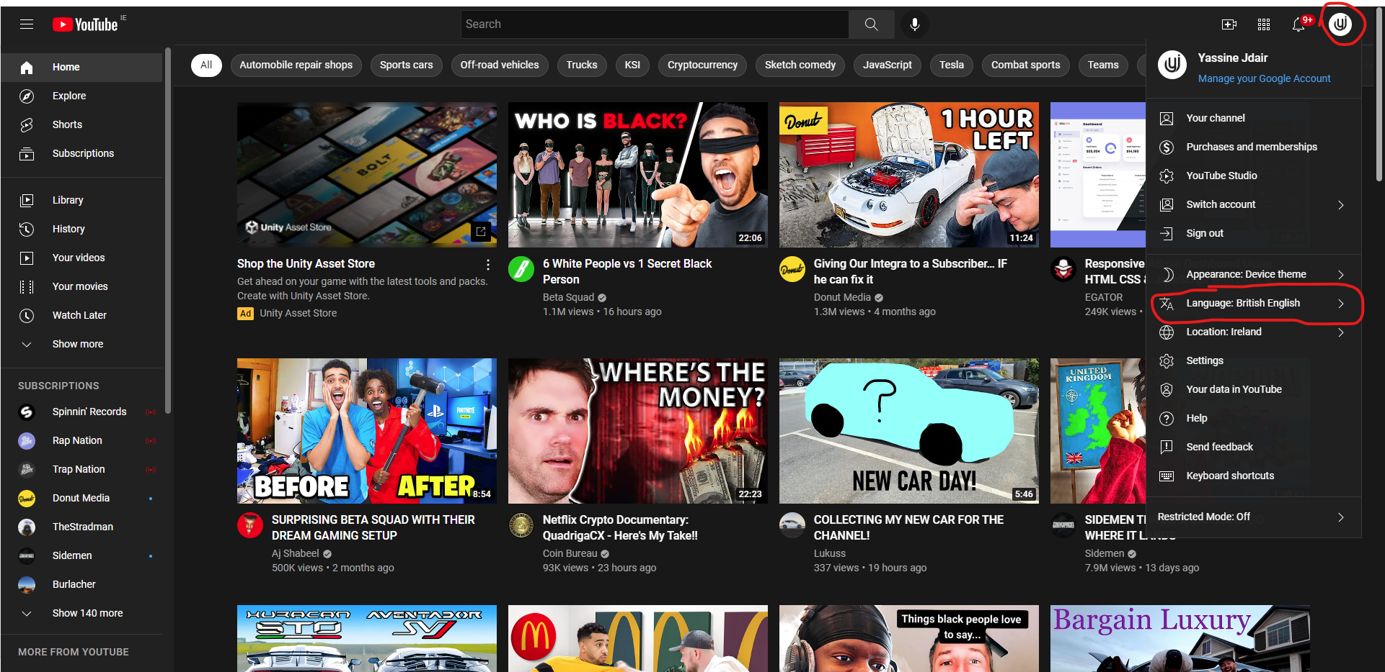

**Feature to test SignIn Panel:**

1. Browse to <http://www.youtube.com>
2. Click Sign in icon located on top right
3. Enter valid email address and password and press next.

**SignIn Panel shows up successfully**



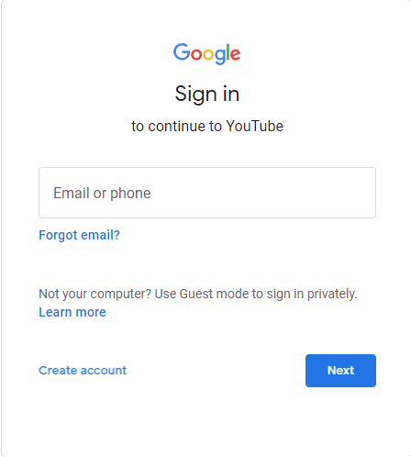

**Feature to test SignIn Error message validation:**

1. Browse to <http://www.youtube.com>
2. Click Sign in icon located on top right
3. Enter valid email address and wrong password and press next.

**User has been prevented from logging in and continuing as password provided is incorrect.**



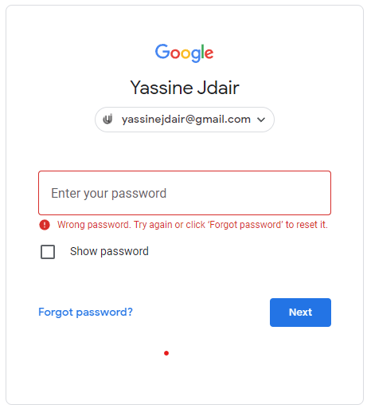

**Feature to test SignIn Error message validation:**

1. Browse to <http://www.youtube.com>
2. Click Sign in icon located on top right
3. Enter valid email address and no password and press next.

**User Unable to proceed as no password was entered**

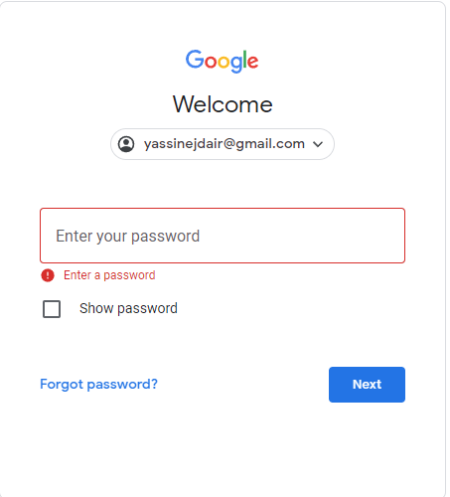

**Feature to test SignUp feature:**

1. Launch www.youtube.com and press the sign in button located on the top right of the navigation panel
2. Press the Create Account button under learn more, the select if you’re making an account for yourself, your child or for your business.
3. Enter your first name, last name , email address(if you don’t have one press create a Gmail address instead) and password with 8 characters into the dedicated text boxes
4. Press the next button.
5. Enter your phone number, recovery email address if you have one, your DOB and finally your gender. Then press next.
6. Choose Personalisation settings. Express which is quicker or manual where you choose your settings.
7. Confirm your privacy settings, agree to terms.
8. Your account has now been created.

**If all steps are done correctly user will be able to sign up and directed to home page of youtube**

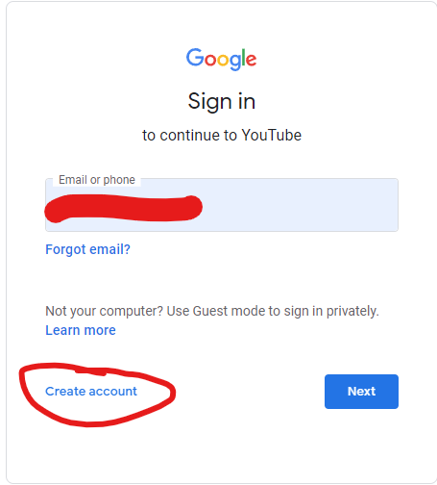

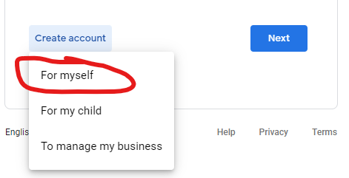

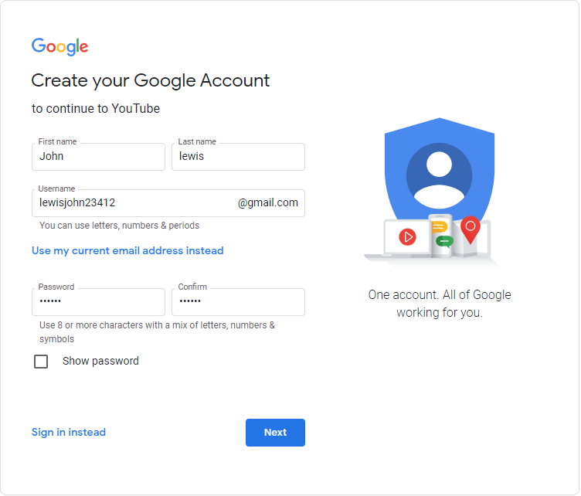

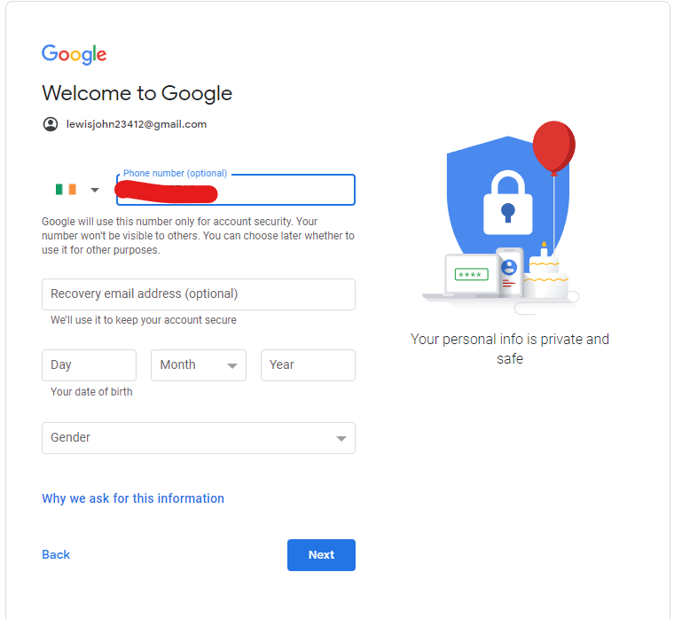

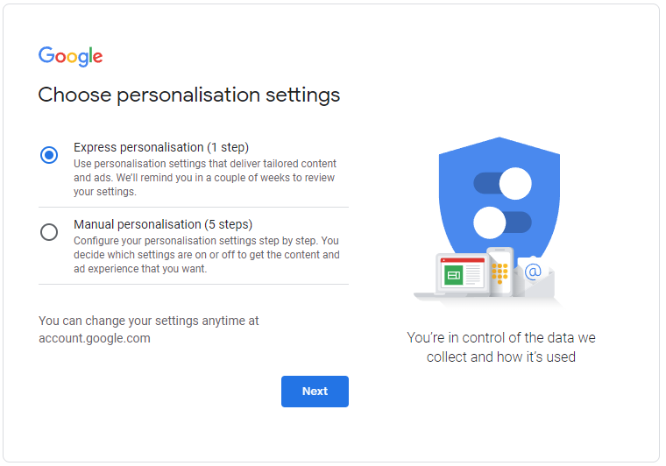

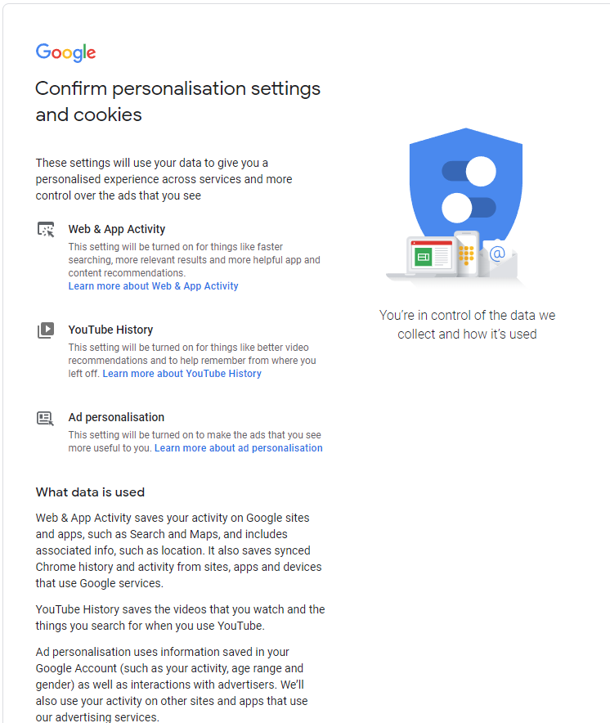

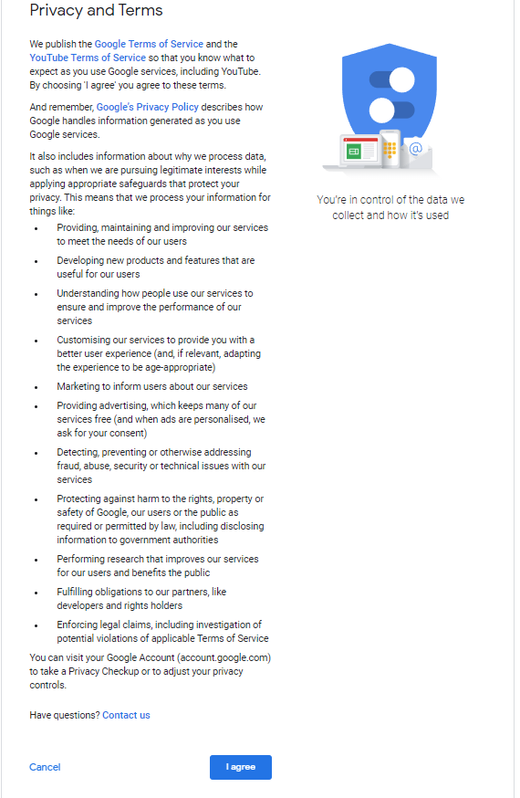

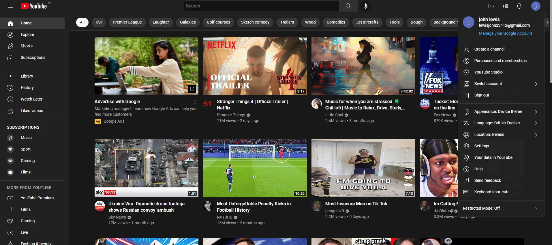

**Feature to test Youtube SignUp validation:**

1. Launch www.youtube.com and press the sign in button located on the top right of the navigation panel.
2. Press the Create Account button under learn more, then select if you’re making an account for yourself, your child or for your business.
3. Enter your first name, last name , email address(if you don’t have one press create a Gmail address instead) and password with illegal characters or different passwords into the dedicated text boxes.
4. Press Next

**User unable to proceed as passwords don’t match.**





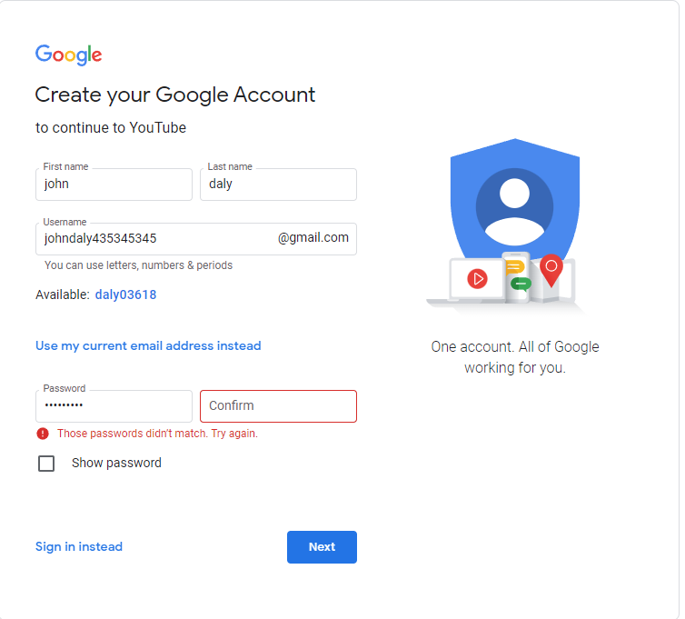

**Feature to test Youtube SignUp validation:**

1. Launch www.youtube.com and press the sign in button located on the top right of the navigation panel
2. Press the Create Account button under learn more, then select if you’re making an account for yourself, your child or for your business.
3. Enter your first name, last name, and an existing email address

**If user enters existing email address, they will have to make up a different one**



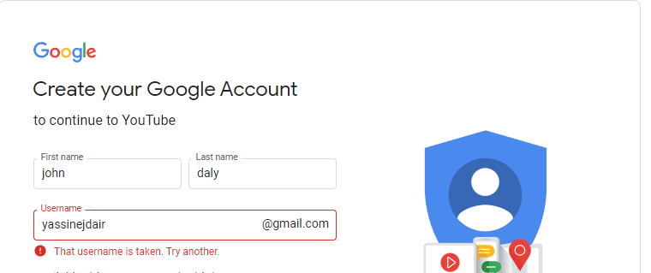

**Feature to test password Reset:**

1. Launch www.youtube.com and press the sign in button located on the top right of the navigation panel
2. Enter email and press the button 'Forgot Password?'
3. Navigate to your email address in a separate tab and click the link flagged 'Reset Password ' and enter your new password of 8 characters or more and press the blue reset password Button.
4. Repeat Steps 1 and sign in with your usual Username and your new password.



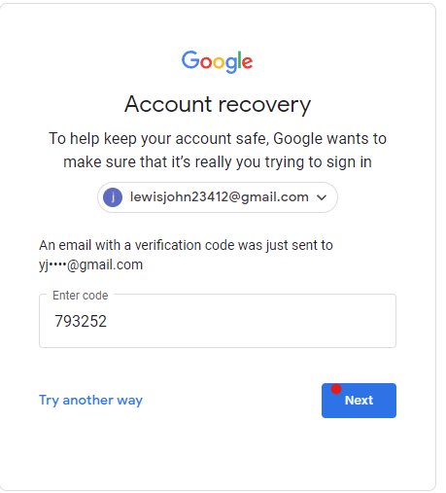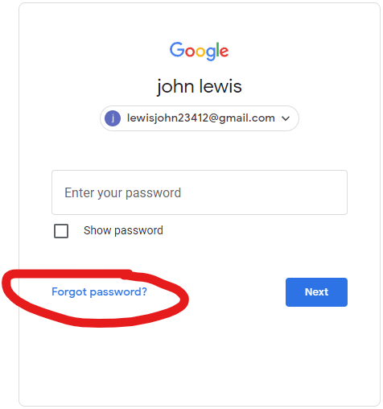

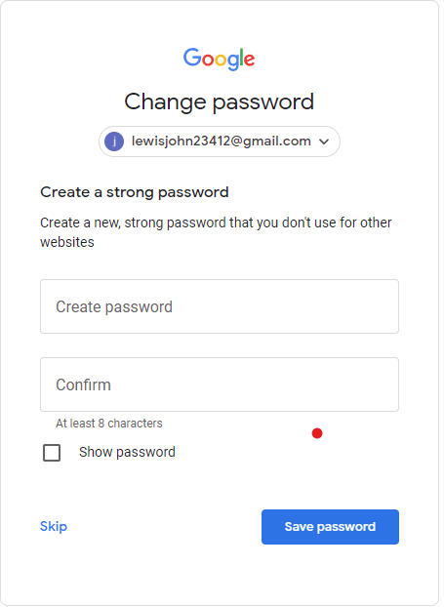

**Feature to ensure search engine works:**

1. Launch www.youtube.com and press the Search bar in the centre of the navigation panel.
2. Type in whatever you’re interested in
3. Hit the search icon or press enter on your keyboard
4. A list of results will appear once you hit enter.

Users keywords will show a list of results related to it.

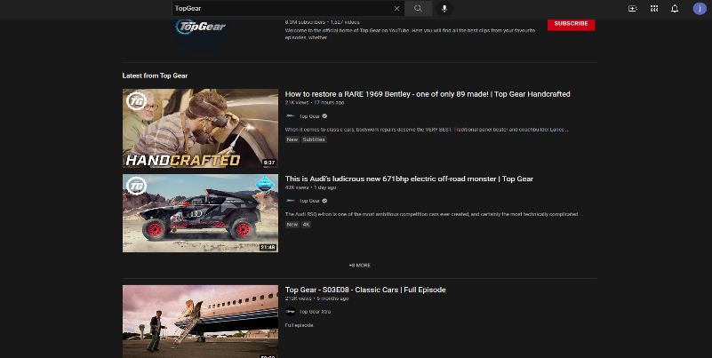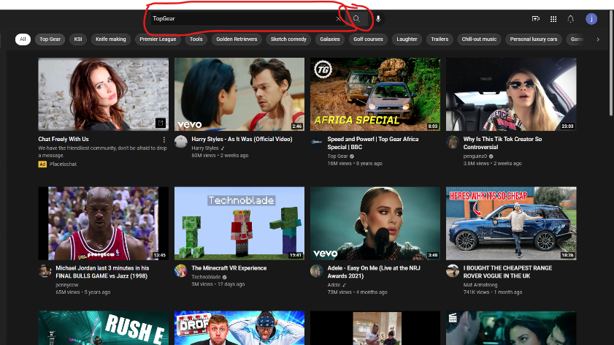

**Feature to ensure subscription Works:**

1. Launch www.youtube.com and press the Search bar in the centre of the navigation panel
2. Type in whatever you’re interested in
3. Hit the search icon or press enter on your keyboard
4. A list of results will appear once you hit enter.
5. Press filters underneath the search bar
6. In the type of Panel select Channel
7. Select the channel you are interested in and Hit the Subscribe button

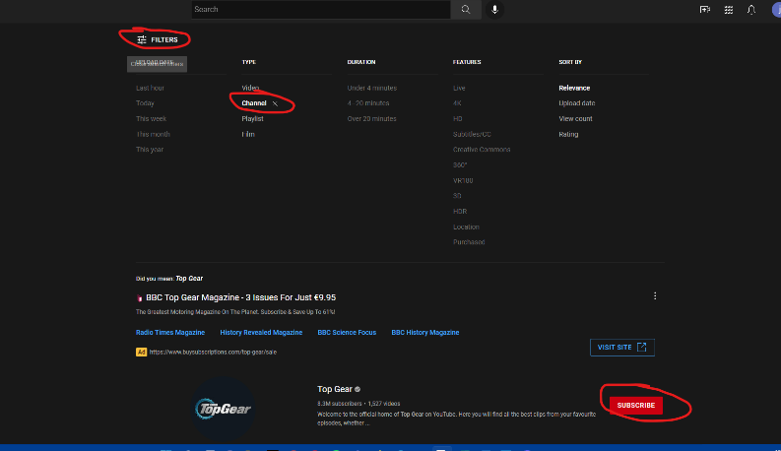**User Should be successfully subscribed to the YouTube channel.**

**Feature to ensure LogOut Works:**

1. Launch www.youtube.com and press the User icon on the top right corner of the navigation panel
2. Select the sign out option

**User Successfully logged out and redirected to home page.**

